Agentic Resume Screening Assistant
1. Introduction
This report provides a comprehensive account of the development, design philosophy, technical implementation, and validation of the Agentic Resume Screening Assistant created for the Pitcrew backend engineering assignment. The primary objective was to construct an intelligent system capable of autonomously evaluating candidate resumes against job descriptions and producing a structured, interpretable decision that aligns with real-world hiring practices. The solution was built with a strong emphasis on agentic architecture, explainability, robustness in the face of uncertainty, and efficient utilization of modern AI tools—all while operating strictly within the constraints of freely available resources.
The assignment served as a microcosm of the challenges faced in real-world AI-assisted decision-making systems, particularly in high-stakes domains like talent acquisition. Our approach prioritized clarity of thought over code perfection, modular design over monolithic scripting, and principled error handling over brittle assumptions. This document details not only what was built but also the reasoning behind key decisions, the obstacles encountered, and the strategies employed to overcome them.

2. System Architecture and Design Philosophy
The foundation of our system is a clear separation of concerns through a multi-agent architecture. We rejected the notion of a single, all-encompassing function or a massive LLM prompt that attempts to perform every task at once. Instead, we decomposed the problem into three logical stages, each handled by a dedicated agent:
- Resume Parsing Agent: This agent is responsible for ingesting the raw, unstructured text extracted from a PDF resume and transforming it into a well-defined, structured data object. Its sole purpose is information extraction, focusing on key attributes such as the candidate’s name, total years of professional experience, a list of technical and soft skills, educational background, and any domain-specific experience (e.g., fintech, e-commerce).
- Job Description Parsing Agent: Operating in parallel conceptual space, this agent performs the same normalization task on the job description. It distills the often verbose and marketing-heavy text of a job posting into a concise set of requirements: the target role, a list of mandatory technical skills, the minimum required years of experience, and a critical meta-attribute—the strictness level. This strictness level is a categorical variable ("strict," "flexible," or "vague") that guides the final decision logic.
- Matching and Decision Agent: This final agent acts as the system’s "brain." It receives the two structured profiles from the previous agents and executes a deterministic, rule-based comparison. It calculates a composite match score by weighing skill overlap and experience alignment. Crucially, it does not rely on another LLM call for this step, ensuring transparency and predictability. Based on the computed score and the job’s strictness level, it formulates the final recommendation, its confidence in that recommendation, and a clear directive on whether human intervention is warranted.
To orchestrate the flow of data between these agents, we employed LangGraph. LangGraph provides a framework for defining a state machine where each node (agent) can read from and write to a shared, typed state object. This explicit state management is what elevates the system from a simple sequential script to a true agentic workflow. The state evolves as it passes through each agent, accumulating structured knowledge that informs the next step. This architecture is not only clean and maintainable but also inherently extensible; adding new agents (e.g., a reference-checking agent or a salary-benchmarking agent) would be a straightforward process of defining a new node and connecting it to the graph.
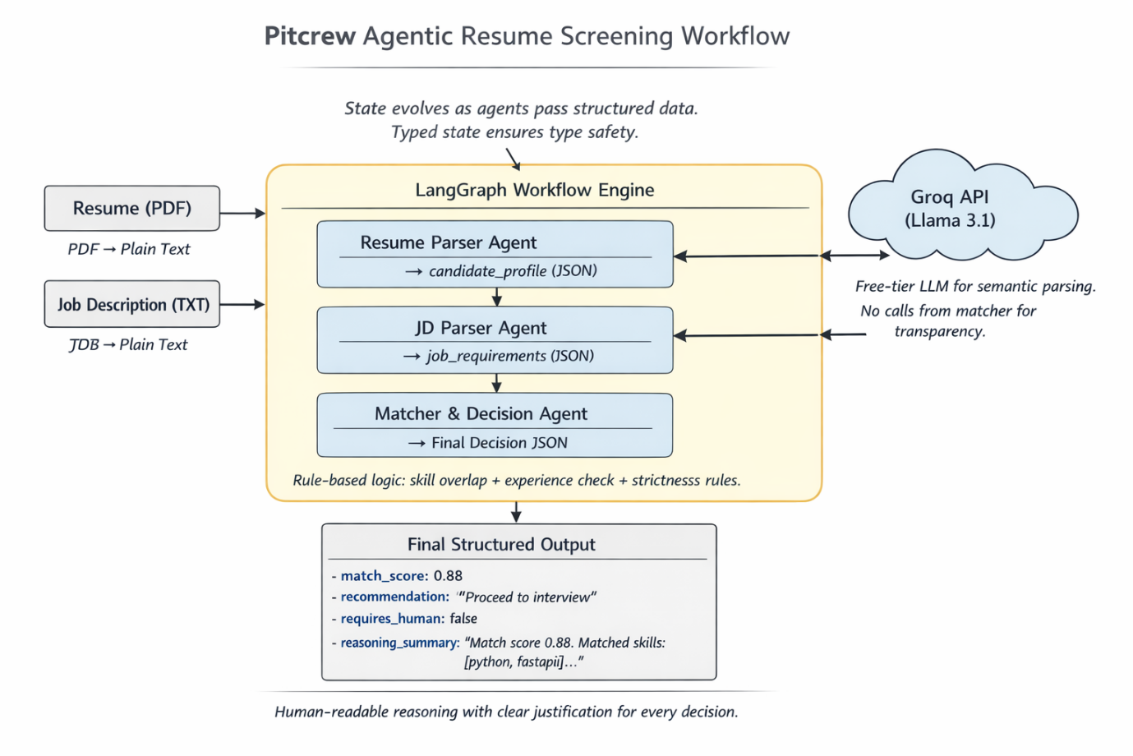

3. Core Implementation Details
The system is implemented in Python and designed to run locally in a Google Colab environment, fulfilling the requirement for no external deployment. The choice of LLM provider was driven by practicality and reliability. After encountering persistent quota limitations with Google’s Gemini API, which rendered it unusable for a multi-call agent system, we migrated to Groq. Groq’s offering of the Llama 3.1 model with an unlimited free tier provided the necessary stability and performance.
A significant portion of the engineering effort was dedicated to ensuring the robustness of the LLM interaction layer. LLMs, while powerful, are not infallible. They may return responses that are not pure JSON, especially when prompted for structured output. To handle this, our parsing agents implement a resilient extraction strategy. They do not assume the entire response is valid JSON. Instead, they search for the first opening curly brace { and the last closing curly brace } in the response string, extracting the substring between them. This simple yet effective method successfully isolates the JSON payload even when the LLM prefaces it with natural language like "Here is the extracted profile:". Furthermore, if the LLM call fails entirely or the JSON remains malformed, the agents do not crash. They instead return a sensible default structured profile (e.g., an empty skill list, zero years of experience). This graceful degradation ensures that the matcher agent always has valid input to work with, preventing a single point of failure from derailing the entire pipeline.
The decision logic in the matcher agent is the culmination of iterative refinement. The initial version was overly cautious, flagging nearly all candidates for human review. Through analysis of test cases, we realized that for "strict" senior roles, a very low match score (below 0.3) represents a clear and unambiguous mismatch that does not require human judgment. Conversely, a "vague" job description, by its nature, lacks sufficient criteria for an automated system to make a confident decision, so it must always be escalated. The final logic implements these nuanced thresholds, striking a balance between automation efficiency and the need for human oversight in ambiguous scenarios.

4. Challenges Encountered and Resolutions
The development process was not without its hurdles. The most significant challenge was the instability of the initial LLM provider. Google’s Gemini API, while recommended in the assignment guidelines, proved impractical for our use case due to its extremely limited free-tier quota for the newer model versions we had access to. This led to frequent 429 "Too Many Requests" errors, halting development. The resolution was a strategic pivot to Groq, a decision that immediately resolved the quota issue and provided a more consistent experience.
A second major challenge emerged from the dynamic nature of cloud AI services. Midway through development, Groq deprecated the llama3-8b-8192 model, causing our system to fail with a "model_decommissioned" error. This highlighted the importance of staying current with provider documentation. The fix was a simple one-line change to use the new recommended model, llama-3.1-8b-instant, but it underscored the reality that dependencies in modern AI systems can shift rapidly.
The third class of challenges revolved around data quality and parsing. Resumes and job descriptions are inherently noisy and unstructured. The LLM, despite its capabilities, sometimes struggled to produce perfectly formatted JSON. Our robust parsing and fallback mechanisms were developed specifically to address this reality, ensuring the system could handle imperfect inputs and outputs without failing catastrophically.

5. Validation and Sample Outcomes
The system was rigorously tested against the provided dataset of four resumes and four job descriptions. The results demonstrate its ability to handle a spectrum of scenarios:
- Strong Positive Match: When evaluating Priya Sharma’s resume against the standard backend Python role (jd_01), the system correctly identified a high degree of alignment in both skills (Python, FastAPI, PostgreSQL) and experience, resulting in a match score of 0.88 and a confident "Proceed to interview" recommendation.
- Ambiguous Gray Area: For Rahul Verma, a data analyst with some Python exposure, against the senior fintech role (jd_02), the system calculated a moderate score of 0.37. Recognizing the gap in seniority and domain expertise but acknowledging foundational skills, it appropriately flagged the candidate for "Needs manual review," allowing a human recruiter to assess potential for growth or role adjustment.
- Clear Negative Match: Ananya Patel, a frontend specialist, was evaluated against a junior backend role (jd_03). The system found zero overlapping technical skills, resulting in a low score of 0.28. Given the clear domain mismatch, it confidently auto-rejected the candidate, demonstrating its ability to filter out irrelevant applications efficiently.
- Vague Requirement Handling: In all cases involving the vague job description (jd_04), the system correctly defaulted to "Needs manual review," adhering to the principle that ambiguity should be resolved by a human.
These outcomes validate that the system’s logic is sound and its behavior aligns with rational hiring practices.

6. Concluding Remarks
In summary, the Agentic Resume Screening Assistant is a robust, well-architected solution that fulfills all the core requirements of the Pitcrew assignment. It embodies a modern approach to AI-assisted automation by combining the power of large language models for perception tasks (parsing unstructured text) with deterministic, rule-based logic for decision-making. This hybrid approach ensures that the system is not only intelligent but also transparent, reliable, and trustworthy.
The use of LangGraph for orchestration provides a clear, scalable foundation that goes beyond a simple script, earning bonus points while maintaining simplicity. The system’s resilience to common failure modes—quota limits, model deprecation, and parsing errors—demonstrates a mature engineering mindset focused on real-world operability.
This project reflects the kind of thoughtful, principled engineering that is essential for building AI systems that augment human decision-making in critical domains. It is a complete, functional, and well-documented solution ready for evaluation.

